**Primary Target Keyword(s)**

Warehouse Fans

Warehouse ceiling fans, warehouse cooling fans, warehouse fans for sale, warehouse industrial ceiling fans, warehouse industrial fans, commercial warehouse ceiling fans, big fans for warehouse, big warehouse fans

**Body Copy**

# H1: INDUSTRIAL WAREHOUSE FANS

**Take Control of Your Warehouse Environment**

Your customers are counting on you for everything from timely production output to well-maintained facilities, while your employees are looking to you for a safe, comfortable work environment. By adding Hunter Industrial Fans to your warehouse or material handling facility, your staff, equipment, and production schedule will quickly benefit.

Button: [GET A QUOTE](https://industrialfans.hunterfan.com/pages/get-a-quote) Button: LEARN MORE

## H2: HVLS WAREHOUSE FANS

Large warehouse cooling fans, known as HVLS (High-Volume, Low-Speed) fans, are an effective and efficient way to keep your warehouse safe, comfortable, and productive. Hunter HVLS ceiling fans are third-party certified by AMCA International and are backed by a Limited Lifetime Warranty. Here are just a few ways warehouse ceiling fans elevate your workspace:

* Create a near 10°F cooling effect.
* Mitigate the effects of humidity.
* Increase productivity.
* Reduce winter heating costs by up to 30%.
* Aid in employee retention.
* Reduce the effects of moisture, odors, and fumes.
* Generate year-round savings.

**INDUSTRY PAGE IMAGE(1)**

**INDUSTRY PAGE IMAGE (2)**

## H2: BENEFITS OF AIR CIRCULATION

As you work hard to keep your team on track, our warehouse ceiling fans work to keep workers comfortable and safe. Our industrial ceiling fans and air circulators bring consistent movement to each area of your space to reduce slick surfaces, deter pests and odors from settling, and control moisture. Your employees, product, and equipment will quickly feel the improvements. **LEARN MORE**

**INDUSTRY-LEADING EFFICIENCY - PRODUCTS STAY ON EACH PAGE**

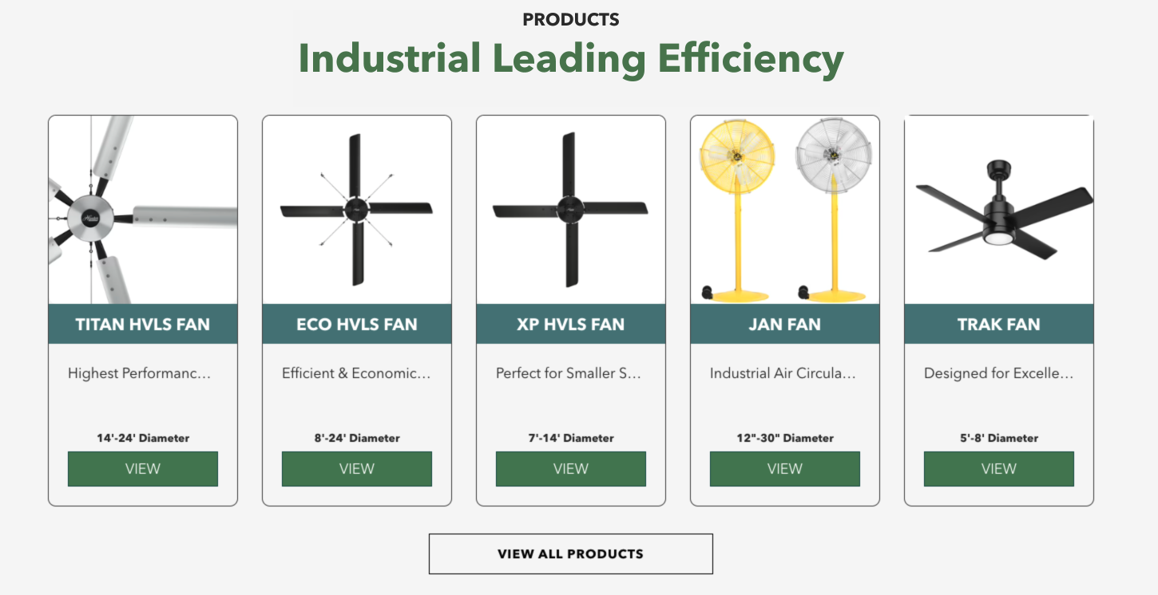

### H3: INSTANTLY UPGRADE YOUR WAREHOUSE SPACE

## “This fan has been nothing short of incredible. It’s completely changed the environment of our warehouse, moving air throughout our entire facility so that the atmosphere is fresh and breathable. Our warehouse crew does hard, heavy labor, and investing in an industrial fan has allowed us to reinforce to our employees that their health and happiness matters.” – Brittney Davis, UltraTech International Inc.

## H2: INDUSTRY LEADING WARRANTY

Not only are Hunter industrial ceiling fans engineered for peak performance and reliability, but our HVLS fans are also backed by a Limited Lifetime Warranty! We trust in the quality of our products, that is why our Titan, ECO, and XP HVLS ceiling fans are backed by the best warranty in the industry. Terms apply, learn more [HERE](https://cdn.shopify.com/s/files/1/0555/5434/3079/files/Hunter_Industrial_Warranty_Statement_2022_2.pdf?v=1662491932).

**INDUSTRY PAGE IMAGE (3)**

**INDUSTRY PAGE IMAGE (4)**

#### H2: WORLD CLASS CUSTOMER SERVICE

From order and delivery to installation and cleaning, we are there when you need us! Have a question or concern? Contact us today at 1-844-591-3267.

H3: CHECK OUT OUR SHOWROOM (Video)

Explore the product offerings from Hunter Industrial & Commercial!

Button: SEE ALL VIDEOS

### H3: Frequently Asked Questions

- Who makes the best warehouse fans?

Hunter Industrial & Commercial offers a variety of warehouse fan options to meet your needs. With multiple sizes, blade numbers, input power options, and mounting options, Hunter is sure to have an industrial ceiling fan that fits your space.

- How to cool a warehouse with fans?

Cooling a warehouse with air conditioning alone is difficult and expensive. Industrial ceiling fans create a cooling effect of up to 10°F, making your warehouse space safer, cooler, and more productive all year long.

- How to position warehouse fans?

This depends on the size of the warehouse and the diameter of the fans installed. A 24-foot Titan HVLS fan has a max affected area of 22,500 feet, whereas a 7-foot XP has a max affected area of 4,900 feet. To ensure properly spaced fans, contact the experts at Hunter today!

#### Contact us.

Related Articles

#### H2: KEEPING THE SUPPLY CHAIN MOVING IS WHAT YOUR FACILITY IS BUILT FOR.

Adding safety and security to your space is what Hunter Fans are designed for. Together, we can craft a plan specific to the unique needs of your material handling space. Click below to connect with one of our experts now!

[GET A FREE QUOTE](https://industrialfans.hunterfan.com/pages/get-a-quote)